[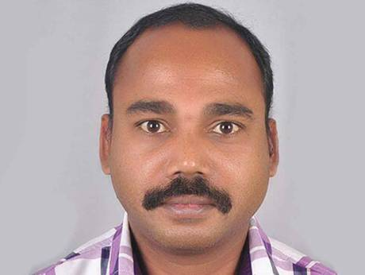](https://www.google.fr/url?sa=i&rct=j&q=&esrc=s&source=images&cd=&cad=rja&uact=8&ved=2ahUKEwj4pu3W3bnZAhWHAcAKHX92DYEQjRx6BAgAEAY&url=http://gulfnews.com/news/uae/emergencies/indian-man-commits-suicide-in-sharjah-1.2043042&psig=AOvVaw3KEj_qG7p-xXEYHDnBShGt&ust=1519396080887825)**Krishna Burak Guillory, 51**

**Nationality: Indian**

**Owner of a small fast-food**

Krishna likes to keep an eye on WhichSandwich as he likes to update his menu with new options to please his customers. He is looking for innovative yet simple (easy to make, accessible ingredients) sandwiches to compete with the growing amount of rival fast-food chains. As he has a wide-range of customers, he is very interested in discovering different type of sandwiches (vegan, vegetarian, halal…) to fulfil their demands.

He does not get involved as far as uploading content to the website, but he has created a user profile to benefit from the “favourite” option. Krishna takes pride in keeping his business well-organised, and he makes sure to use this option to keep track of his most successful sandwiches. He is also very interested by the ranking page, as this gives him a good overview of which sandwiches are most likely to sell well if he decides to start producing them.

**[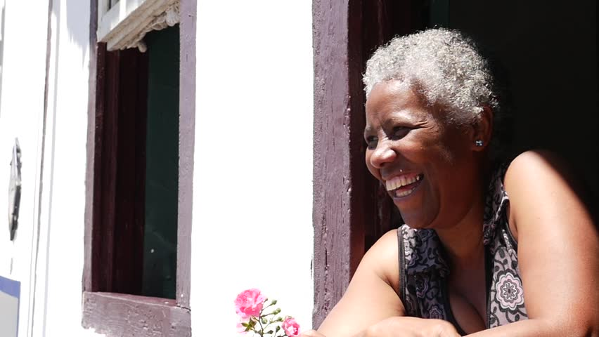](https://www.google.fr/url?sa=i&rct=j&q=&esrc=s&source=images&cd=&cad=rja&uact=8&ved=2ahUKEwiZ387B-rnZAhWoK8AKHS4vAg8QjRx6BAgAEAY&url=https://www.shutterstock.com/fr/video/clip-12193778-stock-footage-brazilian-woman-smiling-from-the-window.html&psig=AOvVaw18KL_17OairAilrVtpaVgD&ust=1519403721069189)**

**Suzana Maria Havelka, 68**

**Nationality: Brazilian**

**Retired**

Suzana spent her entire life in Brazil, where she now enjoys a peaceful retirement in Bangu, Rio de Janeiro. She often takes care of her grandchildren as their single father, her son, spends most of his time working at sea to provide for his family. Suzana places family above all, and desires the best for her grandchildren; she also wants to keep up with her time, and is a regular user of WhichSandwich. She likes to try new, sometimes unheard of, sandwich recipes for when she has her grandkids stay with her. With the time she had on her hands, she has already tried all the most popular sandwiches from this website, and is always looking for new ones.

Aside from trying out the different sandwiches, Suzana also likes to upload her own creations which often comprise local Brazilian ingredients such as Brazil nuts, erva mate or coloral.

**[](https://www.google.fr/url?sa=i&rct=j&q=&esrc=s&source=images&cd=&cad=rja&uact=8&ved=2ahUKEwiLm7-3gLrZAhVBLMAKHVtdDzIQjRx6BAgAEAY&url=http://launchpad516.com/main/links/10-ways-running-business-changed/attachment/business-man-in-tie-for-npra/&psig=AOvVaw3T_CcyO5sNz1UZKAQZgs4k&ust=1519405415762787)**[**Andrew**](https://www.behindthename.com/name/andrew)[**Herman**](https://www.behindthename.com/name/herman)[**Mayes**](https://surnames.behindthename.com/name/mayes)**, 33**

**Nationality: Canadian**

**Entrepreneur**

Andrew has created his own start-up 5 years ago which has since then experienced growing success. This comes at a price, as Andrew must work around 50 hours per week to ensure the well-being of his company. As a result, he does not have time to go out for lunch and often finds himself eating in his office. He has discovered WhichSandwich when he realised he was not having proper healthy meals, which was taking a toll on his efficiency at work. He decided to use this website to make himself a sandwich early in the morning before he left for work. His primary concern is the calories included in his meals, as he wants to make sure he remains productive. He also enjoys some variety in the different sandwiches he prepares for himself.

He is not afraid to purchase high quality ingredients to prepare his meals, although they often come at a higher price. However, he will avoid sandwiches with too many ingredients, or unclear preparation instructions (i.e. No pictures) as his time in the morning is also very limited.